Humorous Lock and Key Puzzle – Feed the Boi

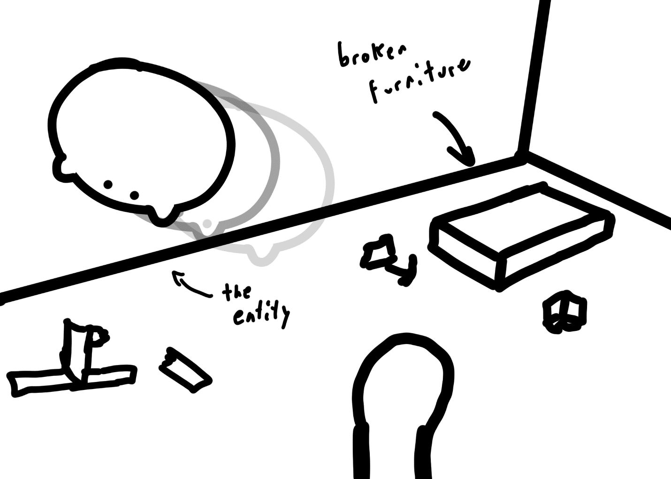

You live in your apartment with your “pet”. You must feed him.

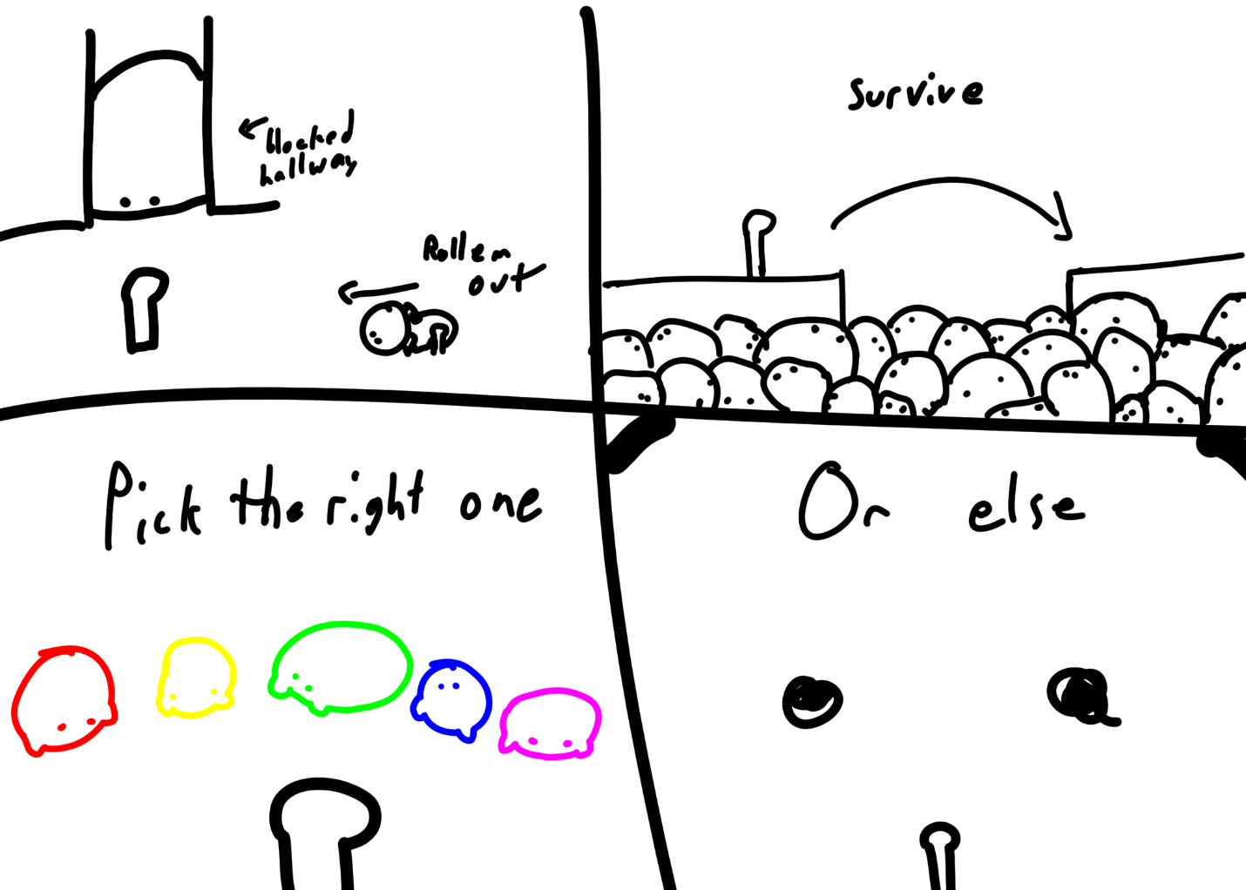

You must overcome challenges in your way in your home to reach the “feed”. Choose the correct one, or else.

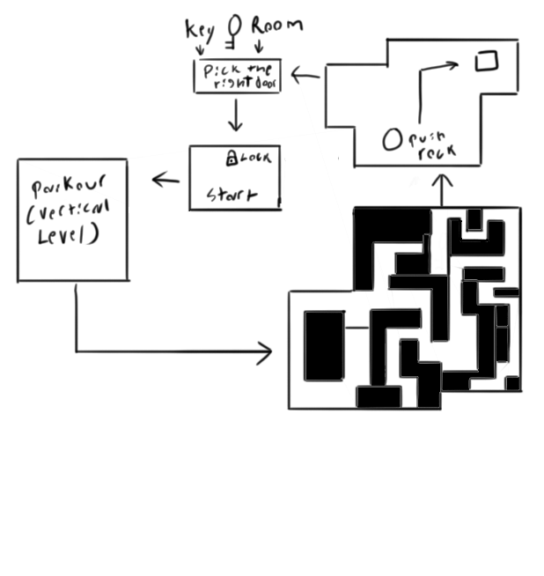

Level Layout

* Start in the room with the entity bouncing around breaking furniture. Text will appear that says “Feed him”, and the color of the text will match the required key.
* You walk to a room with hundreds of “creatures” beneath that you don’t want to fall into. You must carefully jump and parkour your way to the next room
  + This could be themed like a living room or kitchen with various shelves and tables you have to jump across
  + If you fall in, the player would reset at the beginning of the course
* You end up in a maze of broken house and ceiling, fallen bookshelves, etcetera. Find your way up, down, and through to the next room.
* Finally, there is a very fat entity very much in your way. Push it and any others away so you can reach the door
  + Constricting hallways forcing the player to consider which direction they must push it, and how they will get to one side or another to push it better.
* Find your way to the key room, with 5 different colored entities. The player must infer that the right one to pick up is the one that matches the color of the text in the first room.
  + As a secret ending, you could add a door to simply leave the apartment and never come back
  + Either this room would lead to a previously unopened door that leads directly to the first room, or the player would backtrack through the level. Playtesting will indicate which is more enjoyable
  + As you hold the feed, it makes squeaky toy noises at you. Perhaps whenever you jump or move?
* Feed the boi. Feed him right, you get the good ending. Feed him the wrong one, you become the feed.

Humor Idea

The subversion with the cute but terrifying entities is part of the fun, as well as the environmental details of the broken apartment. The player questions how this person came to live like this.

Sounds

*  Furniture smashing noises
* Example sound of the keys protesting their acquisition

Credits

* Concept, game design – Stefan
* Level design – Trey
* Sound effects - Zachary